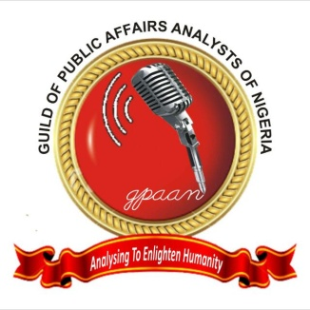

**GUILD OF PUBLIC AFFAIRS ANALYSTS OF NIGERIA**

***….analyzing to enlighten humanity***

*Plot 69/3A, Behind RCC Estate Phase 6, Trans-Ekulu, Enugu*

*Tel 08023594781, 07036243682. Email:gpaanenugu@gmail.com*

**ENUGU STATE CHAPTER**

15th October, 2024

**PRESS RELEASE**

**GUILD OF PUBLIC AFFAIRS ANALYSTS CONDEMNS EFFC INVASION OF URBAN RADIO, ENUGU**

The Guild of Public Affairs Analyst of Nigeria, Enugu State Chapter, received with dismay, the news of the invasion of Urban Radio in Enugu, by agents of the Economic and Financial Crimes Commission (EFCC), Enugu Zonal Office. It was alleged that agents of EFCC, in a gestapo style, yanked off Favour Ekoh, a presenter of Urban radio, while she was still presenting on live radio.

The actions of EFCC at Urban Radio, Enugu, on the 14th of October, 2024, is reminiscent of the fascist, despotic and dark era in Nigeria’s history where all efforts were made to intimidate, harass, bully and silent the media. The EFCC has, again demonstrated, that though we are in a democratic dispensation, it continues to operate as though we are in authoritarian government.

While we understand that the EFCC, as an agency of government, is authorized to carry out its statutory duties, this must, however, be done in accordance with laid down rules of engagement. The arrest of a journalist, while on a live programme, is an affront on free speech and attempt to cow journalists. It is a huge infringement on journalistic practice which is guaranteed under the constitution of the Federal Republic of Nigeria.

We call on the National hierarchy of the EFCC to investigate this matter and bring the erring officers to discipline. The media industry has consistently collaborated and partnered with the EFCC. The actions of overzealous officers of the Commission might jeopardize this mutual relationship if necessary actions are not taken.

**For: GPAAN, Enugu Chapter**

**Ambrose Igboke, PhD, FICMC, ANIPR Dr. Chikezie Obasi**

***Chairman Secretary***

*Ambrose Igboke, PhD - Chairman * Uchenna Cyril Anioke, PhD -Vice Chairman * Chikezie Obasi – Secretary * Uchenna Gabriel - Assistant Secretary *Clinton Umeh- Financial Secretary * Augustine Okolie, PhD - PRO *Prof. Chiwuike Uba -Welfare Officer * John Nwobodo -Legal Adviser*